User Manual

Contents
User Manual 1
Getting Started 1
Request forms 3
1. Incident 3
2. Service Request 4
3. Information 4
Different status of the Ticket 5
Accessing Ticket Details 5

Getting Started

Please login to https://business.quotient.com/ and click on “Technical Support” chiclet to login to Zendesk support. You would have already received a welcome email from Okta in your inbox with subject "Welcome to Quotient Business" to complete the registration process. This will have a link to activate your account (within 7 days), refer to the sample email screenshot (page 2)
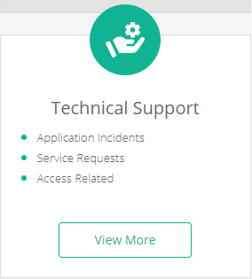

Note: In case if you didn’t received an email from Okta already for the activation of account, please send out an email to CISupport CISupport@quotient.com with “Need access to Technical Support QBS - <User Name>” subject

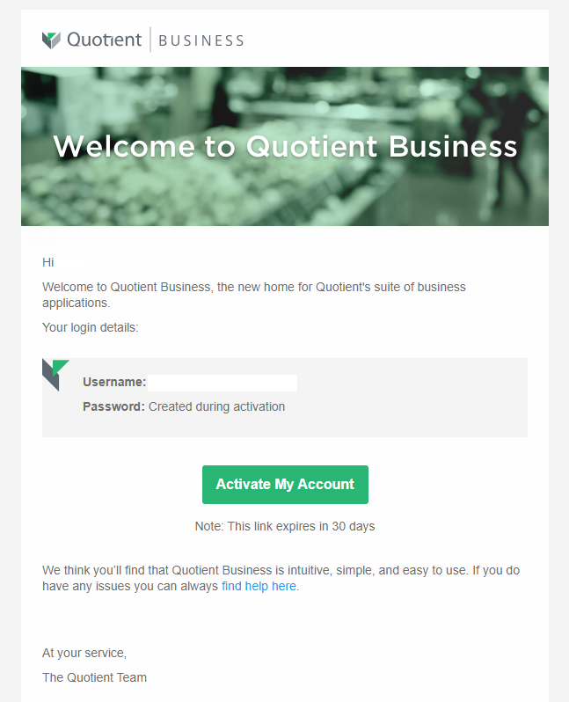

Upon activating the account, the user could go back to the portal and log a ticket for Quotient Support. User would see Submit a request tab on the top right of Zendesk portal.
Request forms
We have broadly classified the requests into 3 different categories, as mentioned below.

1. Incident
- Subject: (Please add a title suggesting the issue in PDN/Prod)
- Environment: (Please choose the environment were the issue is observed either Production or Staging)
- Priority: (Please choose the priority of the issue based on the impact and urgency.)
- Description: (Please enter the details of your request. A member of our support staff will respond as soon as possible)
- Attachments(optional): (Add file or drop files here)

Please hit the 'Submit' button & the request would be raised at our end. The requester would also receive an email for the same.
Please see below screenshot for quick reference.

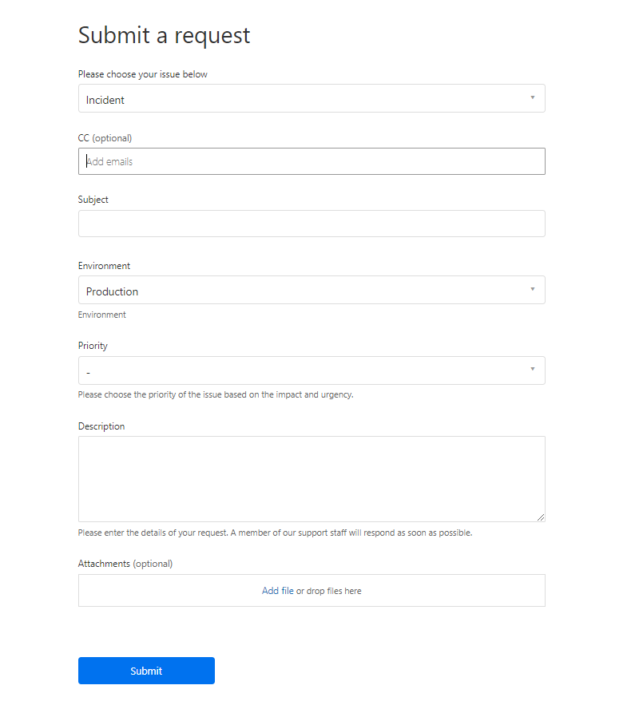

2. Service Request

- Subject :(Please add a title suggesting the service required)
- Environment :(Please choose the environment for the request, either Production or Staging)
- Priority :(Please choose the priority of the issue based on the impact and urgency.)
- Description :(Please enter the details of your request. A member of our support staff will respond as soon as possible)
- Attachments(optional) :(Add file or drop files here)

3. Information

- Subject: (Please add a title suggesting the information shared/needed)
- Description: (Please enter the details of your request. A member of our support staff will respond as soon as possible.)
- Environment: (Please choose the environment for the request, either Production or Staging)
- Attachments(optional): (Add file or drop files here)

Different status of the Ticket

1. New: the request is created and one of our support agents would be looking into it
2. Open: the request is assigned at our end and an engineer is looking at the issue
3. Awaiting your reply: the request needs additional input from requester and will be further investigated accordingly.
5. Solved: the request is complete with no pending deliverables.
6. Closed: the request has been resolved for more than 3 days and is closed now. Create a new request if the issue persists.
Note: Commenting on a ticket with Solved or Awaiting your reply status will reopen the ticket.

Accessing Ticket Details
Upon clicking the user icon, on the top right side, user can access their account activity. They just need to select the first option from the dropdown menu, named My activities. You can also filter the tickets based on the status.
This is further grouped into 3 categories.
My requests: all the requests created by the current user
Requests I'm CC'd on: the requests for which the current user is a participant
Organization requests: the request created by the Organization the user belongs to

